Hands on Tableau Training for Data Science:

# Section -1- It’s super easy to get started.

## What is Tableau and Course Overview

Tableau:

Tableau is a very simple, yet powerful tool for everything to do with data. The company's mission is to help people see and understand data. Tableau is a completely drag and drop software and using Tableau, it is possible to create visuals sometimes ten times faster than what could be created in other programs.

And overall, Tableau is a new and innovative approach to business intelligence.

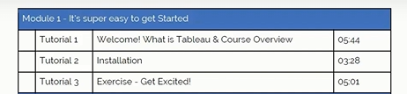

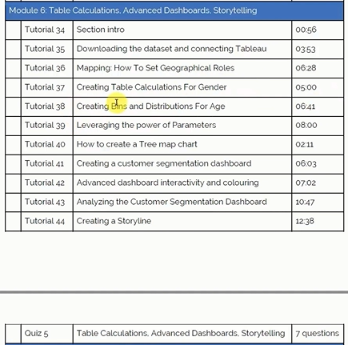

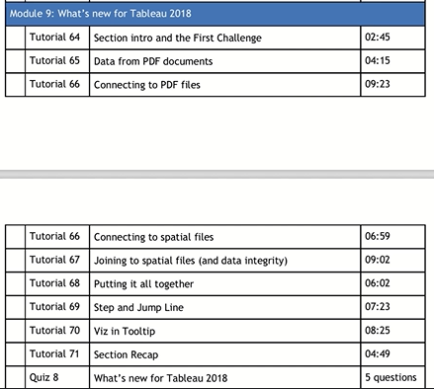

## Installation

Direct download of Tableau which is a 14-day trial

<https://www.tableau.com/>

Tableau Public – FREE

<https://public.tableau.com/app/discover>

## Exercise

To get the Datasets for this course, click the below link

<https://www.superdatascience.com/pages/tableau>

* A Map to show which state has the greater and lesser profits

<https://public.tableau.com/app/profile/sayeesudha.senthil.velan.sayee./viz/SalesprofitinUS/Stateprofits>

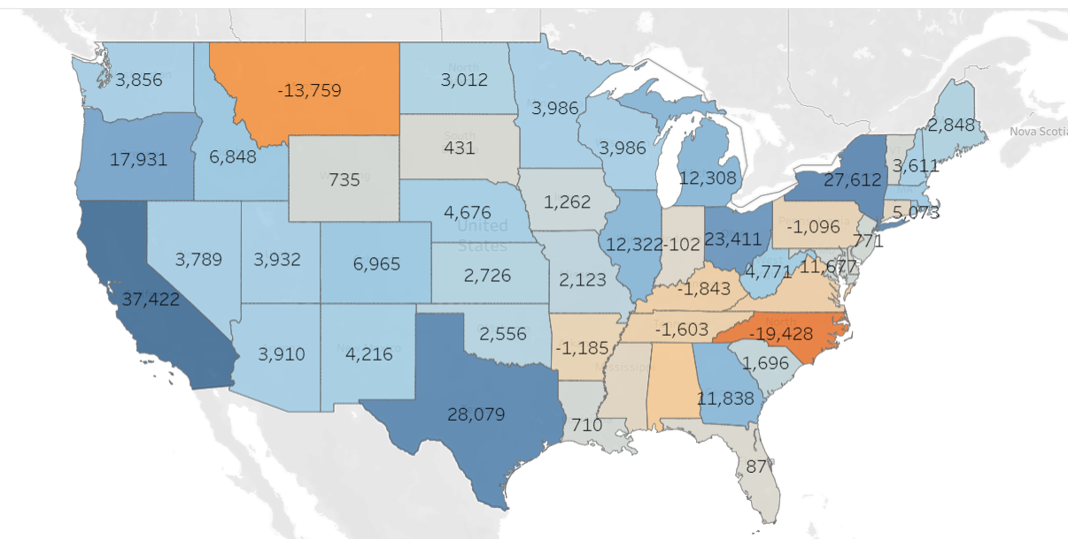

INSIGHTS:

* It is clear that the least profitable state with most losses were incurred in North Carolina
* The most profitable state is California.
* According to the map, these southern eastern states are not doing well except for Georgia and the northern states.
* The western states are doing better when compared to Eastern State except for Montana.

## Get the Datasets here:

Please download the materials required for each section through the link below:

<https://www.artofvisualization.com/pages/tableau>

## Extra Resources:

<https://sdsclub.com/wp-content/uploads/2022/10/WHAT-CHART-TYPE-TO-CHOOSE-FOR-WHAT-DATA.pdf>

<https://sdsclub.com/wp-content/uploads/2022/10/7-Reasons-why-Tableau-Top-BI-tool.pdf>

# Section-2- Tableau Basics: First Bar Chart.

## The Business Challenge – Who gets the annual bonus?

BUSINESS PROBLEM:

It's end of financial year, and that means. It means it's time for annual bonuses.

The store operates in three regions, and only the top performing employee in each region qualifies for a bonus.

Find out which three employees are eligible to get a bonus to get bonuses for this year.

**Employees are measured on the total number or total value of sales.**

|  |
| --- |
| **CSV – Comma Separated Values** |

## Connecting Tableau to a Data File – CSV File

* CSV is opened as text file
* A single Tableau can many datasets and we form relationship between them in the connection manager screen
* Data -> New Data Source -> csv file

## Navigating Tableau

* Data table – it’s on the left and it has two divisions and they are
* Dimensions – quantitative data, independent variables
* Measures- qualitative data, dependent variable
* Worksheet – A single sheet where data analysis is performed
* Dashboards – A combination of worksheets
* Story – A combination of worksheets and dashboards. This is mostly the latest update of Tableau
* Analysis – How you want to perform analysis on the current sheet. Ex- Map
* Format – deals with formatting
* Worksheet
* Column
* Rows
* Show me

## Creating Calculated Fields

* 
* First the chart is broken as regions and following it the Rep data is broken
* Calculated fields – Right click on the unit section 🡪 Create Calculated fields
* By total sales
* 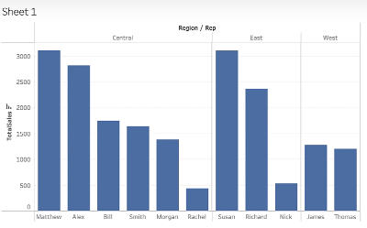
* Bonus – Mathew, Susan and James
* By Unit Sales Result

Bonus - Alex, Richard, James

## Adding Colours

* The Color button in Mark Section is where we could use to change color
* More color patterns can be provided by selecting: Colors 🡪 Edit Colors 🡪 Select Color Palette 🡪 Select anything 🡪 Assign Pallete 🡪 Apply 🡪 Ok
* TIPS – use Ctrl + select the field data in the Columns and Rows for which the colors are needed to be visualized. It is better than pulling the data from the Data sections of the Worksheet area
* 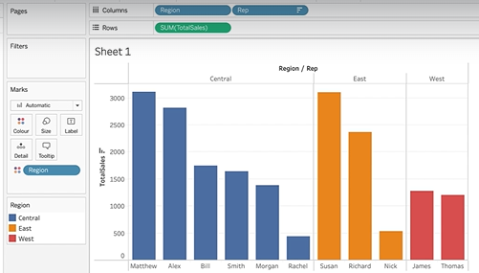

## Adding Labels and Formatting

* How much Bill made?
* Here we can use the Label in Mark section
* Formatting – can be done using the format tab in the Menu bar and this format will be overridden by the Label format in Mark section

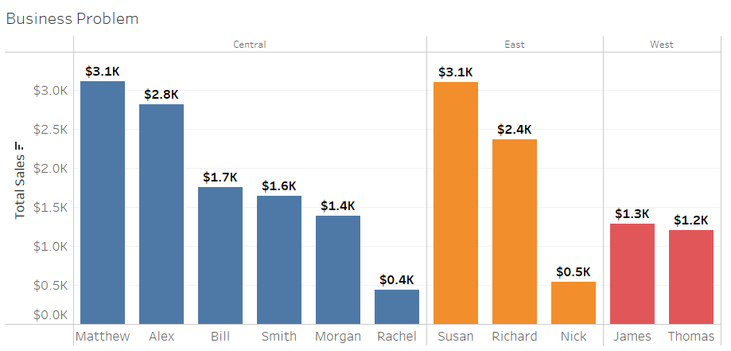

## Exporting Your Worksheet

This cannot be done public version, it can be done in full Tableau Desktop version

* Worksheet 🡪 Copy 🡪 image
* Right click 🡪 copy 🡪 image

## Get the Viz

## Quiz 1:Tableau Basics